

Project Specification
and
Problem Identification Analysis
Report
ICT30016
Technology Innovation Project
Submission date: 1st October 2026
Supervisor name: Dr Kelvin Yong

Student Name | Student Id
Jane Yan Zhen YU | 104395810
Yan Han WONG | 104392138
Bruce Gee Yick WONG | 104401843
Neville Zi Yang | 104400992

Table of Contents
Introduction 1
Part A – Project Specification and Problem Identification Analysis 1
Background of the Project 1
Problem Statement 2
Client Requirements 2
Current Techniques in the Domain 3
Signature-based VS Anomaly-based Detection 3
Machine Learning Approaches 3
Benchmark Datasets and Data Collection 3
Limitations Shared by Benchmark Datasets 4
Feature Extraction Tooling 4
Gaps This Project Addresses 5
Goals/Objectives of the Project 6
Integration of Learning Issues 7
Project Scoping and Deliverables 9
Part B – Team Roles and Management 11
Team Roles 11
Teamwork Roadmap 11
Document Management 12
Project Management Plan 13
References 14

List of Table
Table 1: Client requirements and their alignment with the project goals 2
Table 2: Project deliverables, due weeks and related goals 10
Table 3: Project phases and milestones 13
Table 4: Main project risks and mitigation strategies 13

List of Figure
Figure 1: Suricata running on Windows . 7
Figure 2: Test traffic generated with ping to google.com. 7
Figure 3: Isolation Forest output 8
Figure 4: Output of the second script version. 8
Figure 5: Prototype of the Campus IDS dashboard. 9
Figure 6: GitHub 12

Introduction
University campus networks are busy, open environments where thousands of students, staff and guests connect their own devices every day. Keeping these networks secure is important, because unvetted personal devices connect to them constantly. Most campus IT teams rely on signature-based intrusion detection tools such as Snort or Suricata, which match traffic against rules for known attacks. These tools cannot detect new or modified threats for which no rule exists, and they often generate large numbers of false alarms that bury the alerts that matter. For a small IT team with no budget for dedicated security hardware, this leaves the network exposed to unknown attacks and makes incidents slow to spot.
This project develops a lightweight Intrusion Detection System (IDS) prototype that complements Suricata rather than replacing it. The project has three goals:
- Build a flow-based capture layer that turns Suricata's EVE JSON flow records into features for analysis.
- Integrate an unsupervised Isolation Forest model that learns normal traffic and flags anomalies, including unknown attacks, without needing labelled data.
- Build a real-time dashboard that delivers prioritised alerts to IT staff in under 500 ms, with log storage and CSV export.
The system will be developed and tested only in a controlled lab environment within a 12-week semester.
This report is divided into two parts. Part A presents the project specification and problem identification analysis, covering the background, problem statement, client requirements, current techniques in the domain, project goals, learning issues, and scope and deliverables. Part B describes team roles and management, including the teamwork roadmap, document management, and the project management plan with its milestones and risks.

Part A – Project Specification and Problem Identification Analysis

Background of the Project
University campus networks are busy and open environments where thousands of students, staff, and guests connect their own personal devices every day. Traditionally, network security teams protect these networks using rule-based tools like Snort or Suricata, which compare incoming packets against lists of known attack patterns. These signature-based tools work well for blocking known threats, but they cannot catch new attacks or zero-day exploits because a matching rule simply does not exist yet. [1]

Additionally, widespread network encryption (such as HTTPS and TLS 1.3) prevents deep packet inspection, driving network monitoring toward flow-based analysis of metadata like packet counts, byte rates, and session durations. [2]. Supervised machine learning models struggle to handle novel attacks without large, up-to-date labelled datasets [3]. Using a lightweight, unsupervised anomaly detection model like Isolation Forest on Suricata’s flow data allows the system to learn normal campus traffic patterns and flag unknown threats without requiring dedicated, high-cost server hardware.

Problem Statement
The campus network administration team currently deals with two main problems that make it hard to keep the network safe:

Missing New and Unknown Attacks: Traditional signature-based tools only react after an attack is already known and documented. On an open campus network where unvetted personal devices connect constantly, new exploit scripts, port scans, and unusual traffic patterns slip straight past rule-based firewalls without triggering any warning [1], [3].

High False Positives and Alert Fatigue: Most commercial and open-source security tools trigger huge numbers of low-priority or false-alarm notifications. As Ferrag et al. [1] and Sarhan et al. [3] point out, excessive false alarms are a constant issue in intrusion detection, which wears out staff and leads to real threats being buried or ignored.

Hard-to-Read Tools: Most open-source capture engines only output raw terminal text or giant log files, which are slow and frustrating to read during an incident. Without a clean, real-time dashboard that highlights priority alerts in under 500ms, small campus IT teams cannot quickly spot or react to suspicious activity.

Building a lightweight system that takes flow data from Suricata, checks it with an Isolation Forest model, and pushes clear alerts to a web dashboard solves these exact issues for the campus team.

Client Requirements
The client is the campus network administration team, who monitor and secure the university's internal network. Their main difficulties are alert fatigue from high false-positive rates [4] and the inability of signature-based tools to detect unknown attacks [5]. Table 1 links each requirement to the problem it addresses and to the project goals.

Table 1: Client requirements and their alignment with the project goals
Requirement | Problem addressed | Goal
Real-time alerts in under 500ms | Staff cannot respond before an incident escalates | 1, 3
Detection of unknown (zero-day) threats | Signature-based tools miss new attacks [5] | 2
Fewer, prioritised alerts | Alert fatigue from false positives [4] | 2, 3
Graphical dashboard | Raw logs and command-line output are hard to read | 3
Auditable logs with CSV export | Events must be reviewable and reportable | 3
Low-cost operation on existing hardware | No budget for dedicated security appliances | 1, 2

The client requires the system to stay lightweight, run on existing hardware, and be tested only in a controlled lab environment, without touching the live campus network, within a fixed 12-week schedule. We therefore reuse Suricata instead of writing our own capture engine, and use a lightweight model instead of a deep-learning one

Current Techniques in the Domain

Signature-based VS Anomaly-based Detection
Signature-based detection identifies malicious activity using predefined patterns of known threats, while anomaly-based detection instead flags deviations from a baseline of normal network behaviour ][6]. García-Teodoro et al. [6] note that signature-based schemes perform very well against well-known attacks but cannot detect new intrusions, even when these are only minor variants of known attacks. The main strength of anomaly-based techniques is their potential to detect previously unseen events. The cost is a false-positive rate that is usually higher than that of signature-based systems.

Traditional IDS tools such as Snort and Suricata primarily rely on signature- or rule-based detection [7] [8]. Comparative studies of Snort and Suricata note differences in their architectures and performance, with Suricata’s multi-threaded architecture designed to better utilise multi-core CPUs, while Snort has traditionally relied on a single-threaded architecture [7] [8]. Sharma et al. [9] similarly found differences between the two in processing performance, accuracy, and behaviour under different CPU configurations. This shows that IDS performance depends on the computing environment as well as on detection capability. Despite these differences, both tools remain fundamentally dependent on the quality and coverage of their rule sets.

Suricata, however, is more than a rule engine. It tracks network flows and can export a record for each flow through its EVE JSON output [10], which allows it to serve as a data source for other detection methods.

Machine Learning Approaches
Anomaly-based machine-learning approaches have been widely investigated for network intrusion detection using benchmark datasets. One commonly used dataset is CIC-IDS2017, developed by the Canadian Institute for Cybersecurity, which contains labelled benign and malicious network traffic representing several common attack categories [11]. The dataset provides 78 network-flow features describing characteristics such as flow duration, packet lengths, ports, and TCP flags [12]. Chua and Salam [13] evaluated several machine-learning algorithms for network-based intrusion detection using CIC-IDS2017, including Decision Tree, Random Forest, Support Vector Machine, Naïve Bayes, Artificial Neural Network, and Deep Neural Network. Their experiments demonstrated that conventional machine-learning models can achieve high classification performance on CIC-IDS2017, although performance varies substantially between algorithms and evaluation settings [13].

Benchmark Datasets and Data Collection
The performance reported by ML-based IDS studies depends heavily on the dataset used, so the way each dataset was collected, its size, and its known limitations must be considered when comparing results or selecting data for a new system.

NSL-KDD was derived from the KDD Cup 1999 dataset, which was itself built from the 1998 DARPA intrusion detection evaluation. Tavallaee et al. [14] found that the original KDD data contained a very large number of redundant records, which biases learning algorithms towards frequent records, and that most of its records were so easy to classify that almost any learner achieved high accuracy. NSL-KDD addresses this by removing redundant records and selecting records according to their difficulty level [14], resulting in a training set (KDDTrain+) of 125,973 records and a test set (KDDTest+) of 22,544 records. Each record is a pre-computed connection summary with 41 features, rather than raw packet data. Its main advantage is its manageable size, which allows experiments to run on the complete set so that results from different studies remain comparable [15]. Its main limitation is age: its creators acknowledge that it still inherits some of the problems of the original data and may not be a perfect representation of existing real networks [15], and questions about the accuracy of the underlying DARPA simulations were raised long before NSL-KDD was [6].

CIC-IDS2017 was created in a controlled testbed by the Canadian Institute for Cybersecurity. Traffic was captured from 9 a.m. on Monday, 3 July 2017 to 5 p.m. on Friday, 7 July 2017 [15]. Benign background traffic was generated using the B-Profile system, which models the behaviour of 25 users across HTTP, HTTPS, FTP, SSH, and email protocols [15]. Monday contains only benign traffic, while attacks including brute force, DoS, DDoS, Heartbleed, web attacks, infiltration, botnet, and port scanning were executed on the following [11]. The dataset is distributed both as raw packet captures (PCAP) and as labelled flow records produced by CICFlowMeter, with labels assigned based on timestamps, source and destination IP addresses and ports, protocol, and attack type [15]. Compared with NSL-KDD, it reflects more recent traffic and attack types, but it has its own limitations. Panigrahi and Borah [16] note that it is very large, spread across eight files, contains many redundant records, and suffers from high class imbalance, with attack traffic heavily outnumbered by benign traffic. Engelen et al. [17] later revisited its data-collection pipeline and reported problems in flow construction and labelling, showing that results obtained on the original labelled files should be interpreted with caution.

Limitations Shared by Benchmark Datasets
Both datasets were generated in controlled environments rather than captured from production networks. García-Teodoro et al. [6] describe the trade-off behind this choice: evaluating an IDS on real traffic gives realistic data but risks disrupting normal operations, while experimental environments require realistic synthetic background traffic to be generated, which is far from trivial. As a result, a model that performs well on a benchmark dataset may not perform equally well on a specific campus network, whose traffic patterns differ from those of the testbed.

Feature Extraction Tooling
Machine-learning detectors generally require numerical features rather than raw packets as input, so a feature-extraction stage is needed between packet capture and detection. In intrusion-detection research, this stage is commonly handled by CICFlowMeter. The tool converts captured packets into bidirectional flows and computes statistical features such as flow duration, packet and byte counts, packet lengths, TCP flags, inter-arrival times, and active and idle periods. It was used to produce the flow features of the CIC-IDS2017 dataset [11], and Hofer-Schmitz et al. [18] used it to extract 36 features for their experiments. Their study also shows that feature selection matters, since irrelevant or redundant features increase computational requirements and can affect classification performance [18].

An alternative is to derive features directly from packets in Python using a library such as PyShark, a wrapper around the tshark packet dissector. This offers full control over which fields are extracted. However, flow tracking, flow termination, and feature computation must then be implemented and maintained by the project itself. The performance of that code under sustained campus traffic also becomes the project's responsibility.

A third option is to reuse the flow records already produced by an IDS engine. Suricata's EVE JSON output can log a flow event for each tracked flow [10]. Each event records the number of packets and bytes sent in each direction, the flow's start and end times, its age (duration), its state, and the reason the flow ended [10]. Because these records are produced by Suricata's multi-threaded engine [8], the project does not need to reimplement packet capture or flow tracking. The trade-off is a smaller feature set than CICFlowMeter provides statistics such as inter-arrival times and packet-length distributions are not part of the flow record.

As a result, the detection model must use features that can be computed from Suricata's flow records. A model trained on the full CIC-IDS2017 feature set could not be applied directly to live EVE output. Training therefore needs to use either the subset of dataset features that correspond to EVE fields, or traffic captured through the same Suricata pipeline.

Gaps This Project Addresses
The literature reviewed above points to three gaps relevant to a campus deployment.

The first concerns unknown attacks. Signature-based tools such as Snort and Suricata cannot detect new intrusions for which no signature exists, even when these are only minor variants of known attacks [6]. Supervised ML classifiers, in turn, depend on labelled training data [6]. Anomaly-based detection can potentially detect previously unseen attacks, but usually at the cost of a higher false-positive rate [6]. For this reason, most deployed platforms surveyed by García-Teodoro et al. [6] adopt a hybrid design, combining a signature-based core with a complementary anomaly-based module.

The second concerns practical deployment. García-Teodoro et al. [6] list low throughput and high cost at high network data rates among the main open challenges for anomaly-based detectors. Recent reviews indicate that many ML/DL-based IDS studies still focus on offline evaluation, while computational requirements, inference time, and real-time deployment receive comparatively less attention [19]. Integrating ML models into practical, real-time IDS environments therefore remains an important research direction, particularly where detection performance must be balanced against computational and operational constraints [20].

The third concerns the staff who act on alerts. In a study of Security Operations Centre practitioners, Alahmadi et al. [4] found that practitioners confirmed high false-positive rates from their security tools, which required alarms to be validated manually. A detector that adds alerts without helping staff review them risks worsening this problem rather than solving it.

This project addresses these gaps by complementing an established engine rather than replacing it, in line with the hybrid approach described in [6]. Suricata is retained for packet capture and flow tracking. Its EVE JSON flow records are transformed into features for an Isolation Forest anomaly detector, which requires no labelled attack data and has linear time complexity with a low memory requirement [21]. Detections are then pushed to a real-time dashboard designed for campus IT staff. The aim is to demonstrate that a lightweight anomaly-detection model can be integrated into a usable, operational IDS prototype, rather than being evaluated only as an offline model.

Goals/Objectives of the Project
The main objective of this project is to develop an automated, lightweight Intrusion Detection System (IDS) for campus networks that addresses the client's core issues: alert fatigue and vulnerability to unknown zero-day attacks. To meet the client requirements, we have set three goals.

Goal 1:
Build a flow-based capture layer on top of Suricata. Rather than writing a packet-capture engine from scratch, the team reuses Suricata, which already exports flow-level telemetry such as packet counts, byte counts, and flow duration through its EVE JSON output [10]. The team's contribution is to transform this telemetry into the statistical features required by the detection model, which gives the model more context than inspecting packets one by one [22]. Suricata's multi-threaded architecture also means this groundwork does not need to be reimplemented [8].

Goal 2:
Integrate an Isolation Forest model to classify traffic as normal or anomalous. Signature-based tools only block attacks they already recognise [22], and supervised classifiers such as Random Forest and SVM need retraining when unseen threats appear [23]. A lightweight anomaly-based model instead learns what normal traffic looks like and flags zero-day anomalies without high-end servers.

Goal 3:
Build a real-time dashboard that alerts campus IT staff to threats. Persistent-connection architectures have been shown to deliver messages in under 300ms with over 99% reliability [24], which supports our target of under 500ms. Staff can see alerts immediately and export CSV logs without working in command-line screens.

Integration of Learning Issues
When the team received the project topic, we had almost no experience with network programming, flow feature extraction, or anomaly detection. We identified three knowledge gaps and addressed each with a specific learning strategy.

Gap 1: Network programming and flow-based feature extraction.
None of us had worked with live packet capture or flow aggregation, and the detection model needs flow-level statistics such as duration, packet counts, and byte rates rather than raw payloads [22]. Instead of writing a capture driver from scratch, we selected Suricata and learned to configure it and parse its EVE JSON logs from its documentation and academic benchmarks [8].
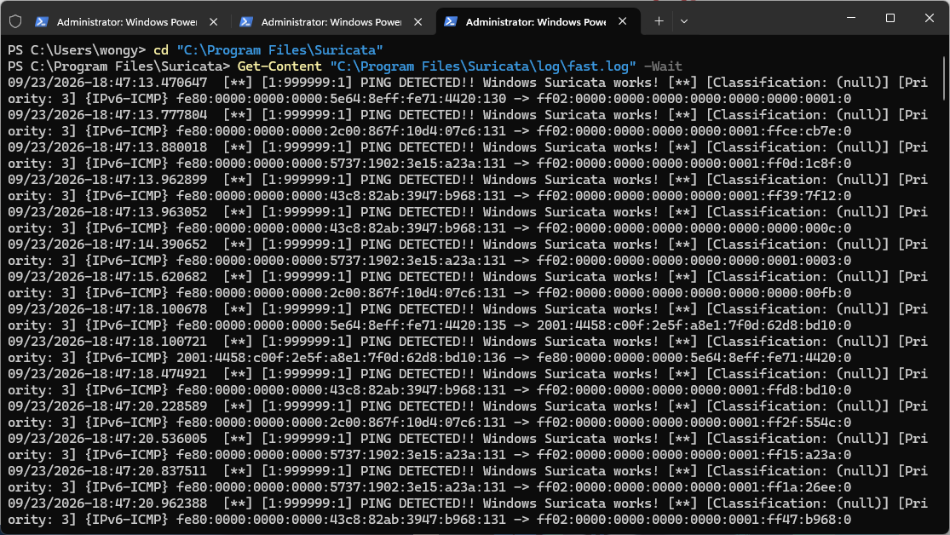
Figure 1: Suricata running on Windows

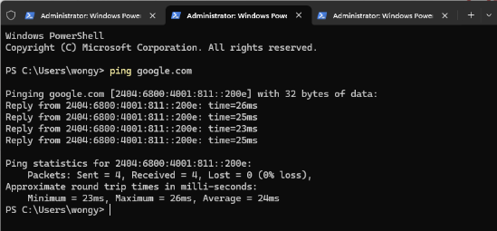
Figure 2: Test traffic generated with ping to google.com

Gap 2: Training and tuning an anomaly detection model.
Isolation Forest isolates anomalies rather than learning from labelled attacks, which differs from the supervised classifiers taught in coursework, and it has been applied to network traffic in IoT settings [25]. We studied the scikit-learn documentation and ran small trials on sample data, adjusting parameters such as the contamination rate. We also found that feature scaling did not change the results, because Isolation Forest's splitting is unaffected by linear scaling of features. We therefore focus on feature engineering instead.
.
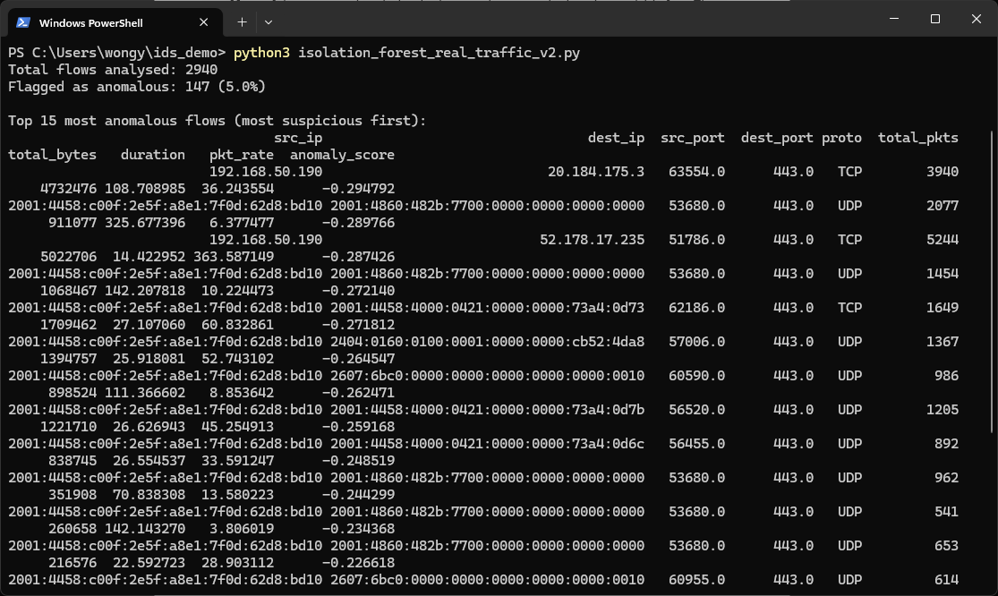
Figure 3: Isolation Forest output
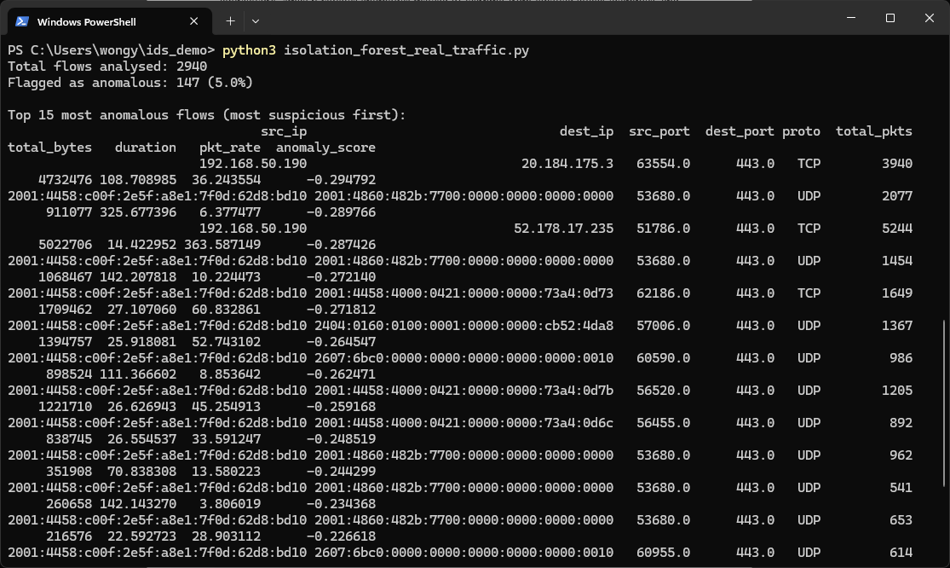
Figure 4: Output of the second script version

Gap 3: Real-time alert delivery.
Pushing alerts without manual page refreshes was new to us. Since WebSocket delivers messages with lower latency than polling [25], we built a prototype that pushes test alerts before connecting it to the detection pipeline.
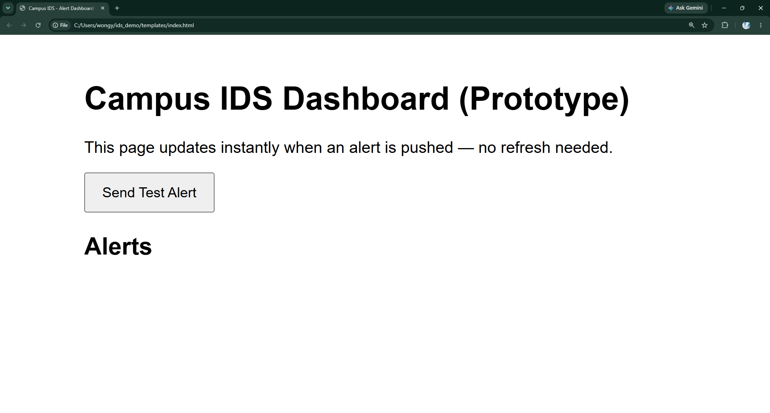
Figure 5: Prototype of the Campus IDS dashboard

Project Scoping and Deliverables
To keep the project manageable within the team's time and skills, we set clear boundaries on what the system will and will not cover.
In scope:
- Capturing live or recorded traffic in a lab environment using Suricata [8], with a Scapy script as a backup.
- Extracting features from Suricata's EVE JSON flow records [10].
- Training an unsupervised Isolation Forest model to flag unknown (zero-day) anomalies.
- A real-time WebSocket dashboard with alert latency under 500 ms, and log storage with CSV export.
- Testing with our own Suricata traffic and public benchmarks (NSL-KDD [14], CIC-IDS2017 [11]). CIC-IDS2017 is a reference only, because its feature set is larger than Suricata's flow records.
Out of scope:
- Deployment on the live campus network.
- Integration with SIEM or firewall systems
- Inspection of encrypted payloads
- Multi-site detection, and commercial development.
Based on this scope, the team will deliver the following components aligned with our milestones:
Table 2: Project deliverables, due weeks and related goals
No. | Deliverable | Due | Goal
D1 | Suricata capture and flow pipeline | Week 6 | 1
D2 | Feature extractor (EVE JSON to numerical features) | Week 8 | 1
D3 | Trained Isolation Forest classifier | Week 10 | 2
D4 | WebSocket dashboard with CSV export | Week 10 | 3
D5 | Testing and evaluation report | Week 12 | 1–3
D6 | GitHub repository with README | Week 12 | 1–3

Part B – Team Roles and Management

Team Roles
Roles were assigned according to the part of the pipeline each member had already taken ownership of during early prototyping (capture, detection, alerting), so that report responsibilities line up with technical responsibilities.

Jane Yan Zhen Yu – Project Coordination and Documentation: manages the overall submission process, divides the report into sections among the team, tracks deadlines against the 12-week schedule, and carries out a final review of the combined report for consistency and formatting before submission. Also researches and writes the Current Techniques in the Domain section.

Yan Han Wong – Capture Pipeline and Prototyping: sets up and configures Suricata for live packet capture and flow tracking, including the multi-threaded engine and EVE JSON output, and built the project's first working prototype, confirming live capture and rule matching (Figures 1 and 2) before the rest of the pipeline was built on top of it.

Bruce Gee Yick Wong – Model Training and Testing: trains and tunes the Isolation Forest anomaly detection model on the flow records produced by the capture pipeline and leads end-to-end testing and evaluation of the system's detection accuracy and alert latency against the project's milestones.

Neville Zi Yang – Dashboard and Alerting: builds the real-time WebSocket dashboard that displays alerts and statistics to campus IT staff, including the CSV log export feature, and coordinates the team's sprint schedule and communication.

Because the pipeline stages are sequential, such as capture, detection, and alerting, the team holds two meetings a week to test each stage together as it is completed, rather than integrating all four parts only at the end.

Teamwork Roadmap
To make sure the project is finished within the 12-week semester, the team is following a simple plan divided into 2-week sprints:

Sprint schedule: Every two weeks, the team focuses on one major set of deliverables (from D1 to D6). We meet twice a week (Tuesdays and Wednesdays) to test our code together, compare experimental results, and fix any bugs early.

Task Distribution: Each member handles a specific part of the project so tasks do not overlap: packet capture setup (Suricata), flow feature extraction, Isolation Forest model training, and the WebSocket alert dashboard.

Communication and Progress: We use a WhatsApp group for quick daily chats and urgent questions, while GitHub is used to track code changes, assign tasks, and review pull requests before merging.

Handling Disagreements: If we disagree on technical decisions like which flow features to pick or how to tune model parameters, we run quick tests and let the actual performance numbers decide. If someone falls behind on their part, tasks are shifted during our weekly meetings, and if a deadlock happens, we will ask our supervisor for guidance.

Document Management
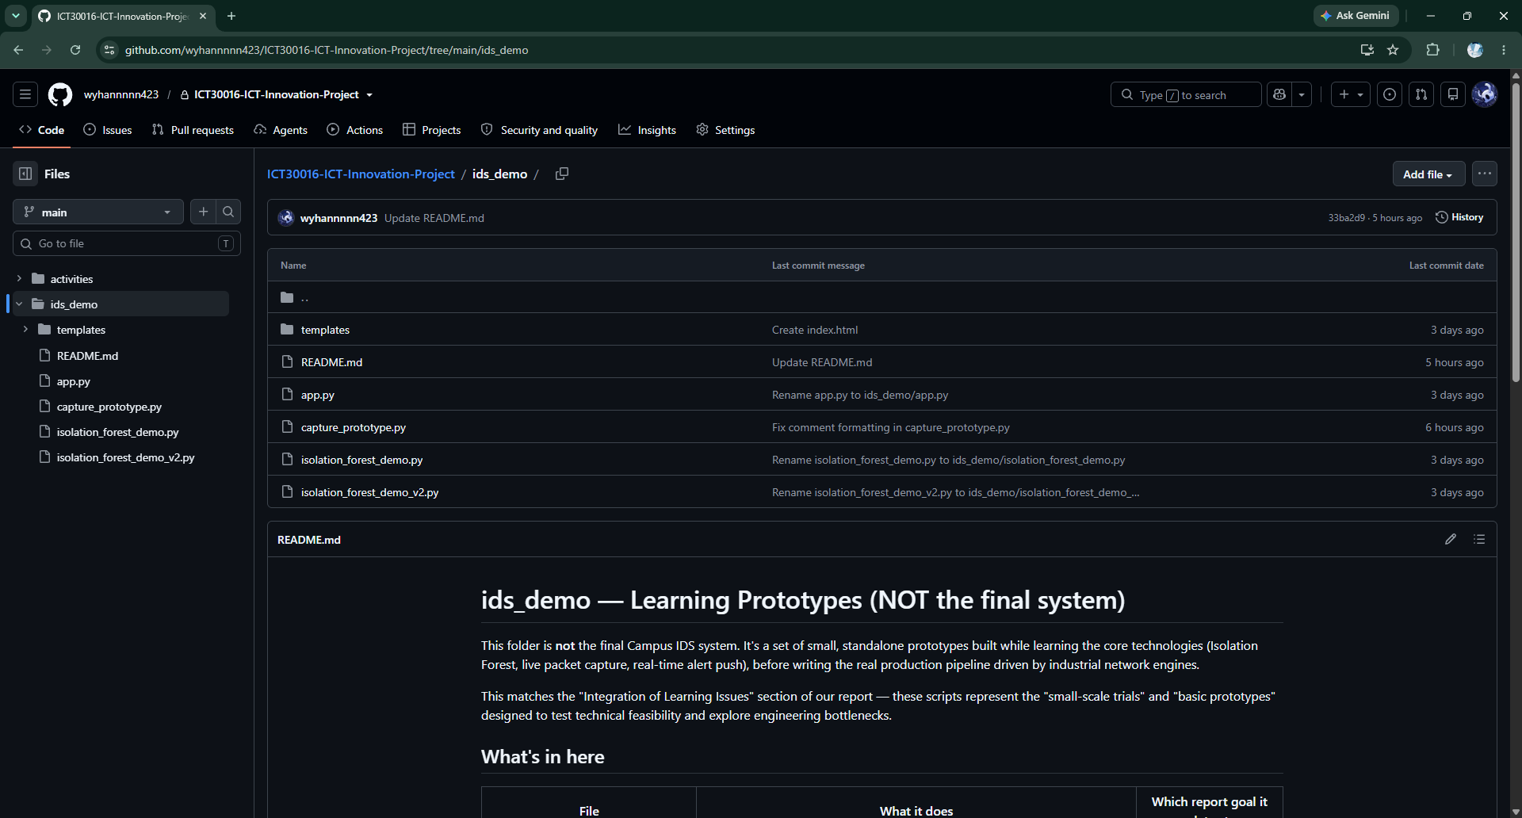
Figure 6: GitHub
All project documentation and source code are managed in a single private GitHub repository shared by all four team members and the supervisor. It holds the feature extraction, model training, and dashboard scripts, as well as workshop notes and weekly progress reports as Markdown files, so everything the team produces is version-controlled in one place.

The team tracks every change through Git commits with clear messages. Each member works on a separate branch for their own task (capture, model training, or dashboard) and merges into main through a pull request reviewed by at least one other member. This prevents members from overwriting each other's work and lets us roll back if a change breaks the system. A README.md documents the setup and how to run the system, and WhatsApp is used to notify the team of significant commits or pull requests.

Project Management Plan
1.Timeline and Milestones

The project runs in four phases over the 12-week semester, each ending with a milestone.

Table 3: Project phases and milestones
Phase | Weeks | Main activities | Milestone
Early prototyping | 1–4 | Form the team, run early Scapy capture tests, tune Isolation Forest on sample data | Problem definition and prototype results
Requirements and capture setup | 5–6 | Finalise scope, set up Suricata and flow pipeline | M1: EVE JSON flow records produced (D1)
Core development | 7–10 | Build feature extractor, train model, build dashboard | M2: Model flags anomalies (D2, D3).  M3: Alerts appear in under 500 ms and CSV export works (D4)
Testing and delivery | 11–12 | End-to-end testing, tuning, final report and repository | M4: Report and repository submitted (D5, D6)

2.Risks and Mitigation

Table 4: Main project risks and mitigation strategies
Risk | Mitigation
Packet drops under heavy traffic, because our early Python capture scripts are single threaded | Hand capture and flow tracking to Suricata [8], so Python only handles flow records. Scapy remains a backup.
Poor detection or too many false alarms from Isolation Forest | Improve feature engineering and tune the contamination rate. If results are still unsatisfactory by Week 9, train a supervised model (Random Forest) on labelled flows from our own Suricata pipeline.
Dashboard latency above 500ms or blocked WebSocket connections | Test the WebSocket prototype early and measure latency at M3. If WebSocket is blocked, fall back to short-interval HTTP polling.

References
[1] M. A. Ferrag, L. Maglaras, S. Moschoyiannis, and H. Janicke, "Deep learning for cyber security intrusion detection: Approaches, datasets, and comparative study," Journal of Information Security and Applications, vol. 50, pp. 1-19, Feb. 2020, doi: 10.1016/j.jisa.2019.102419.
[2] R. Hofstede, P. Čeleda, B. Trammell, I. Drago, R. Sadre, A. Sperotto, and A. Pras, "Flow monitoring explained: From packet capture to data analysis with NetFlow and IPFIX," IEEE Communications Surveys & Tutorials, vol. 16, no. 4, pp. 2037–2064, Fourth quarter 2014, doi: 10.1109/COMST.2014.2321898.
[3] M. Sarhan, S. Layeghy, N. Moustafa, and M. Portmann, “NetFlow Datasets for Machine Learning-Based Network Intrusion Detection Systems,” in Big Data Technologies and Applications: 10th EAI International Conference, BDTA 2020, and 13th EAI International Conference on Wireless Internet, WiCON 2020, Cham, Switzerland: Springer, 2021, pp. 117–135.
[4] B. A. Alahmadi, L. Axon, and I. Martinovic, “99% False positives: A Qualitative study of SOC analysts’ perspectives on security alarms,” 2022. https://www.usenix.org/conference/usenixsecurity22/presentation/alahmadi
[5] A. Khraisat, I. Gondal, P. Vamplew, and J. Kamruzzaman, "Survey of intrusion detection systems: Techniques, datasets and challenges," Cybersecurity, vol. 2, no. 1, pp. 1–22, Jul. 2019, doi: 10.1186/s42400-019-0038-7.

[6] P. García-Teodoro, J. Díaz-Verdejo, G. Maciá-Fernández, and E. Vázquez, “Anomaly-based network intrusion detection: Techniques, systems and challenges,” Computers & Security, vol. 28, no. 1–2, pp. 18–28, Aug. 2008, doi: 10.1016/j.cose.2008.08.003.

[7] A. DeVito. “Suricata vs Snort: A Comprehensive Review.” StationX. Accessed: Sep. 20, 2022. [Online]. Available: https://www.stationx.net/suricata-vs-snort/

[8] D. Sabri Ghazi, H. Shehab Hamid, M. Joudah Zaiter and A. Sabri Ghazi Behadili, “Snort Versus Suricata in Intrusion Detection,” Iraqi Journal of Information & Communications Technology, vol. 7, no. 2, pp. 73-88, Aug. 2024, doi: 10.31987/ijict.7.2.290.

[9] N. V. Sharma, Kavita, G. Aggarwal, and S. Sharma, “Performance study of SnOrT and Suricata for Intrusion Detection System,” IOP Conference Series Materials Science and Engineering, vol. 1099, no. 1, p. 012009, Mar. 2021, doi: 10.1088/1757-899x/1099/1/012009.

[10] Open Information Security Foundation, "Eve JSON format," Suricata User Guide. Accessed: Sep. 24, 2026. [Online]. Available: https://docs.suricata.io/en/latest/output/eve/eve-json-format.html

[11] I. Sharafaldin, A. H. Lashkari, and A. A. Ghorbani, “Toward Generating a New Intrusion Detection Dataset and Intrusion Traffic Characterization,” Proceedings of the 4th International Conference on Information Systems Security and Privacy (ICISSP 2018), pp. 108–116, 2018, doi: 10.5220/0006639801080116.

[12] M. Al Lail, A. Garcia and S. Olivo, “Machine Learning for Network Intrusion Detection—A Comparative Study,” Future Internet, vol. 15, no. 7, pp. 1-17, Jul. 2023, doi: 10.3390/fi15070243.

[13] T. H. Chua and I. Salam, “Evaluation of Machine Learning Algorithms in Network-Based Intrusion Detection Using Progressive Dataset,” Symmetry, vol. 15, no. 6, p. 1251, Jun. 2023, doi: 10.3390/sym15061251.

[14] M. Tavallaee, E. Bagheri, W. Lu, and A. A. Ghorbani, "A detailed analysis of the KDD CUP 99 data set," 2009 IEEE Symposium on Computational Intelligence for Security and Defense Applications), Ottawa, ON, Canada, pp. 1–6, 2009, doi: 10.1109/CISDA.2009.5356528.

[15] Canadian Institute for Cybersecurity, "NSL-KDD dataset," University of New Brunswick. Accessed: Sep. 24, 2026. [Online]. Available: https://www.unb.ca/cic/datasets/nsl.html

[16] R. Panigrahi and S. Borah, "A detailed analysis of CICIDS2017 dataset for designing intrusion detection systems," International Journal of Engineering & Technology, vol. 7, no. 3.24, pp. 479–482, 2018.

[17] G. Engelen, V. Rimmer, and W. Joosen, "Troubleshooting an intrusion detection dataset: The CICIDS2017 case study," 021 IEEE Security and Privacy Workshops (SPW), pp. 7–12, 2021, doi: 10.1109/SPW53761.2021.00009.

[18] K. Hofer-Schmitz, U. Kleb and B. Stojanović, “The Influences of Feature Sets on the Detection of Advanced Persistent Threats,” Electronics, vol. 10, no. 6, pp. 1-22, Mar. 2021, doi: 10.3390/electronics10060704.

[19] H. A. El Shenbary, A. T. A. Elsayed, B. Z. Hassan, K. A. A. Khalaf Allah and A. N. Bakry, “A comprehensive survey of intrusion detection systems in IoT: Datasets, algorithms, and emerging trends,” Applied Computational Intelligence and Soft Computing, no. 1, May 2026, doi: 10.1155/acis/5545578.

[20] A. Kumar, H. Arif, T. Mazhar, G. Aldehim, M. A. Khan and H. Hamam, “Deep Learning Approaches for Intrusion Detection in IoT Networks: A PRISMA-Guided Systematic Review With Descriptive Meta-Analysis,” IET Networks, vol. 15, no. 1, pp. 1-22, May 2026, doi: 10.1049/ntw2.70030.

[21] F. T. Liu, K. M. Ting, and Z.-H. Zhou, "Isolation forest," 2008 Eighth IEEE International Conference on Data Mining, pp. 413–422, 2008, doi: 10.1109/ICDM.2008.17.

[22] G. Fernandes, J. J. P. C. Rodrigues, L. F. Carvalho, J. Al-Muhtadi, and M. L. Proença, "A comprehensive survey on network anomaly detection," Telecommunication Systems, vol. 70, pp. 447–489, 2019.

[23] P. B. Sudasinghe, K. S. K. Liyanage, and H. S. G. Pussewalage, "Lightweight LLMs for network attack detection in IoT networks," 2025 Computing, Communications and IoT Applications (ComComAp), pp. pp. 395-400, 2025, doi: 10.1109/ComComAp68359.2025.11353200.
[24] N. R. Ashfi, "A real-time emergency communication framework using WebSockets and the MERN stack," Journal of Computer, Software, and Program, vol. 2, no. 2, pp. 34–43, Dec. 2025, doi: 10.69739/jcsp.v2i2.1159.

[25] J. Li, X. Zhang, H. Xiang, and A. Beheshti, "Federated anomaly detection with isolation forest for IoT network traffics," 2023 IEEE 29th International Conference on Parallel and Distributed Systems (ICPADS), pp. 2622–2629, Dec. 2025, doi: 10.1109/ICPADS60453.2023.00348.

